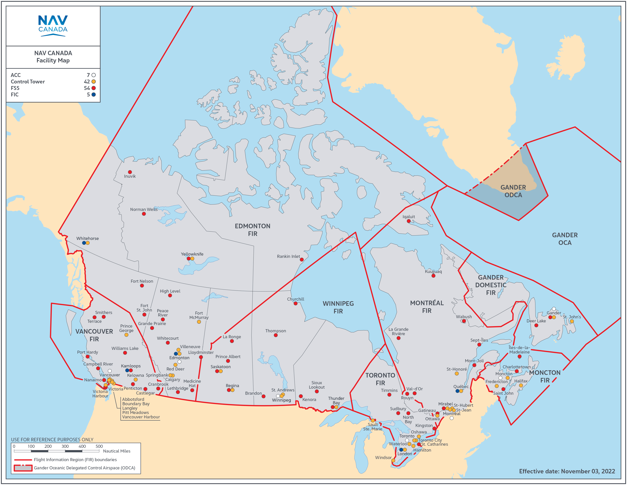
Emergency ATS Contact Numbers by FIR

Emergency Contact Numbers
In controlled airspace, contact the affected air traffic services (ATS) unit at the emergency number on your flight authorization report. In uncontrolled airspace, if your drone enters or is likely to enter into a control zone during ATS unit hours, contact the affected ATS unit.
If your drone enters or is likely to enter Class F Special Use Restricted Airspace, Class E controlled airspace, or a Class E control zone after ATS unit hours, contact the appropriate emergency phone number for your Flight Information Region as listed here.

FIR | Air Traffic Services (ATS) by Region | Phone Number
1 | Gander Flight Information Region | (709) 651-5207
2 | Moncton Flight Information Region | (506) 867-7173
3 | Montreal Flight Information Region | (514) 633-3365
4 | Toronto Flight Information Region | (905) 676-4509
5 | Winnipeg Flight Information Region | (204) 983-8338
6 | Edmonton Flight Information Region | (780) 890-8397
7 | Vancouver Flight Information Region | (604) 586-4500

Flight Information Centre (FIC) – Within Canada, call 1-866-WX-BRIEF
24/7 telephone access for flight operations personnel – Flight Information Centres (FIC),
NAV CANADA can provide interpretive weather briefings, advisory services and flight plan filing by telephone. Within Canada, call 1-866-WX-BRIEF to reach your FIC
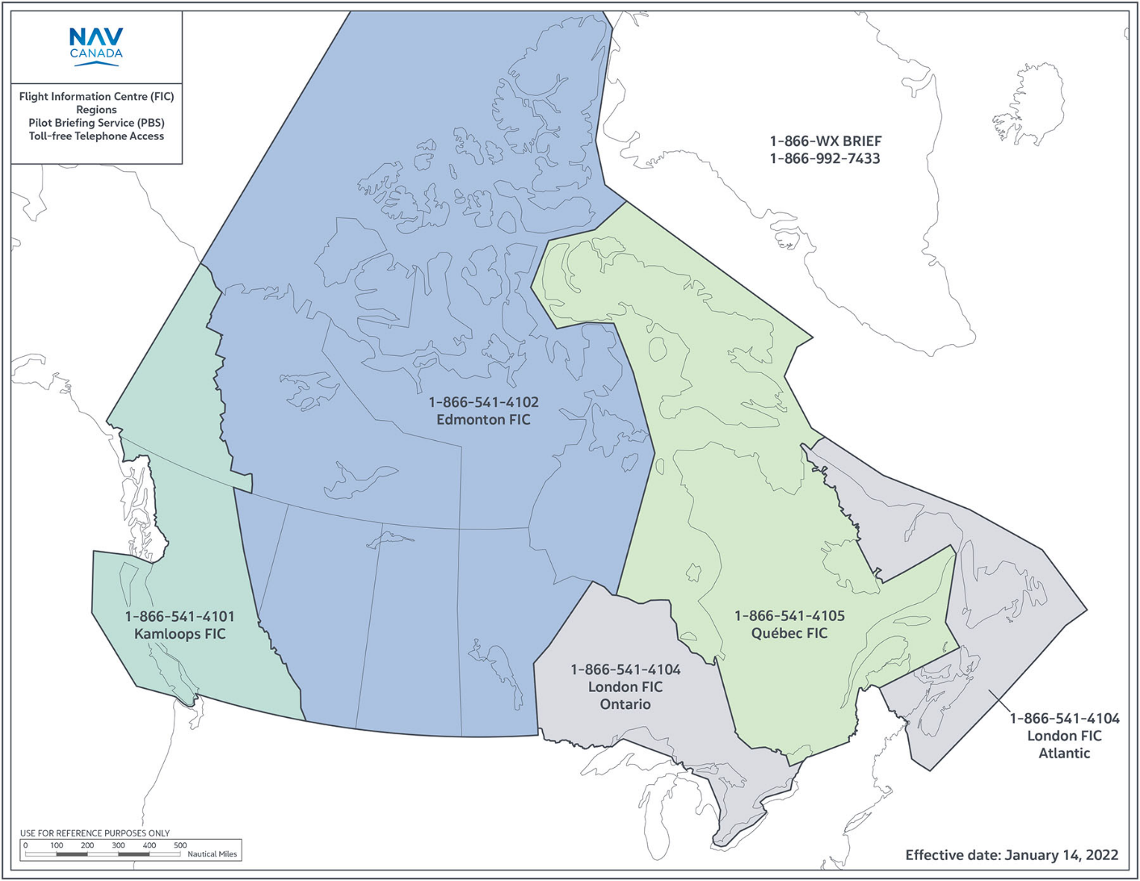
[ NAV CANADA Flight Planning and Reporting ]
https://www.navcanada.ca/en/flight-planning/flight-planning-and-reporting.aspx

Emergencies and Incident Reporting – Transport Canada
https://tc.canada.ca/en/aviation/aviation-accidents-investigations/emergencies-incident-reporting
From: Transport Canada
If you are reporting an emergency (If there is imminent and immediate threat to aviation and public safety), please call our 24/7 Emergency Numbers (toll free):
Voice: 1-877-992-6853
Fax: 1-866-993-7768
Aviation Operations Centre (AVOPS) is the Emergency Operations Centre for civil aviation emergency preparedness activities and occurrence reporting.
- Report an aviation incident (AVOPS)
- Reporting an aviation security incident
- Report and incident affecting airport or aerodrome safety
- Report a drone incident
- Report a Safety Incident at a Cellular Tower or Other Aviation Obstacle
The Transport Dangerous Goods Directorate is the focal point for the national program to promote public safety during the transportation of dangerous goods.
- Report an incident involving dangerous goods
The Transportation Safety Board of Canada is the official source of aviation accident and incident data.
Other useful links:
- Canadian Transportation Agency
- Search Civil Aviation Daily Occurrence Reporting System (CADORS)
- Canadian Transport Emergency Centre (CANUTEC)
- Transportation of dangerous goods — requirement to report a dangerous goods accident
- 2016 Emergency Response Guidebook
- Emergency Response Assistance Plan

